Reflective Portfolio Algebra 1

Unit 2: Solving Equations and Inequalities
At the conclusion of each unit, you will create at least two-page reflective study sheet.
- Write the title of the unit and its number at the top of the page
- Label each section on your sheet

Section 1: Vocabulary (words/ or diagram) Define each of the following:
- What is the difference between an expression and an equation?
- What is the difference between an open circle and a closed one when graphing inequalities on a number line?
- Define Literal Equations
- List the setup of all 3 types of consecutive integers.

Section 2: Formulas and Rules:
- What is the rule when multiplying or dividing by a negative number when solving an inequality?
- $\frac{5}{x}=\frac{3}{x-2}$ Solve and state each number property used in each step.

Section 3: Key Methods and Concepts:
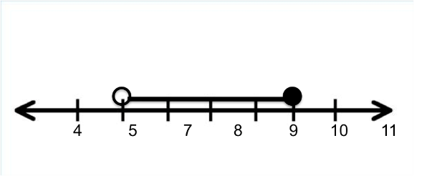
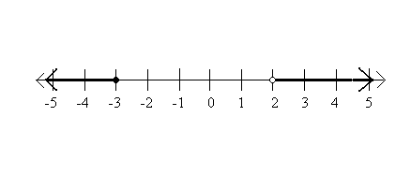
Write an inequality for each to describe the solution set and then write it in Interval notation.

- b)
2.Solve the following equation for x: and describe Number property that is appropriate for each step.
- $\frac{16}{2x}+2=6$; x = 2 b. $\frac{1}{5}x-y=z$
3.Solve the following compound inequalities and represent the solution graphically and in an interval notation:
a. $2x+5≥3 or -3\left(x+3\right)≥6 b. -5<2x+ 1<4$
4.For each of the following word problems define the variables and solve.
- Find three consecutive odd integers such that the sum of the second and third is 55 less than the first. You must define the variables first then find all three integers.{ -61,-59, -57 }
- Lily has 4 more quarters than dimes. If she has $5.20 in quarters and dimes, how many of each type coin does she have??
- The perimeter of a rectangle is 104 feet. The length is two feet more than four times the width. Find the length and the width.
- Dakota begins his kindergarten year able to spell 10 words. He is going to learn to spell 2 new words every day. Determine the minimum number of whole days it will take for him to be able to spell at least 75 words.

All the information that you need to complete this portfolio is in your Do now, notes, and classwork.
This study guide needs to be NEAT and ORGANIZED!

